Repo Order 🡪 <https://github.com/veeramanimanoharan/msbatch3-order-management.git>

Inv🡪 <https://github.com/veeramanimanoharan/msbatch3-inventory-management.git>

Docker Hub – veeramanimanoharan/order & veeramanimanoharan/order

Contents

Maven build inside Jenkins job 1

Order 1

Inventory 2

Docker Images 3

Service as Kubernetes in GCP 4

Swagger Endpoint 7

Postman Endpoints 8

Order 8

Inventory 10

Apigee proxy for Kubernetes 12

# Maven build inside Jenkins job

Jenkins job is configured to Pull the code from the GitHub, mvn clean install, Build docker image and push to docker hub

## Order

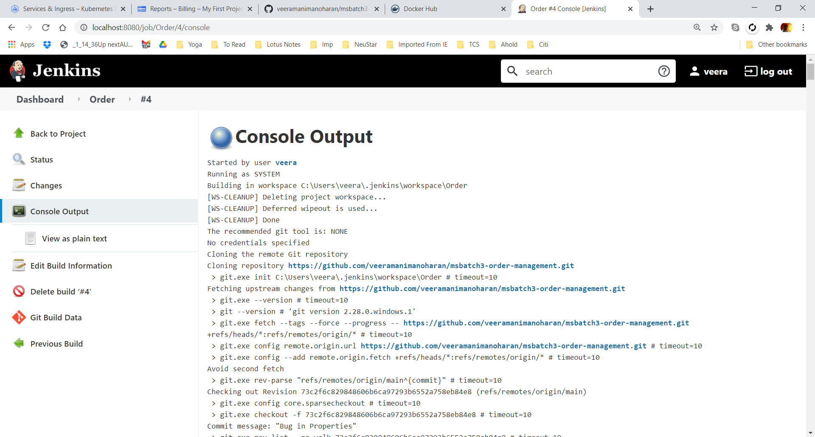

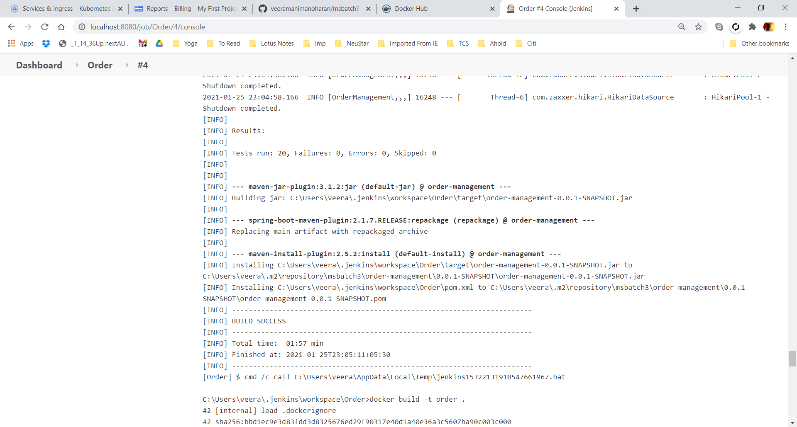

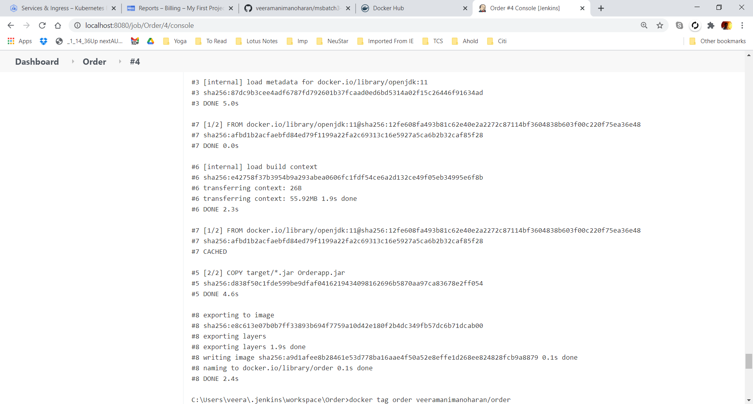

## Inventory

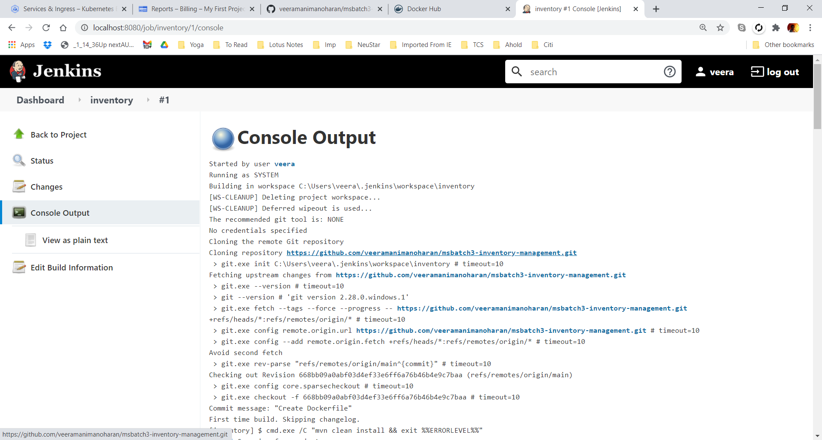

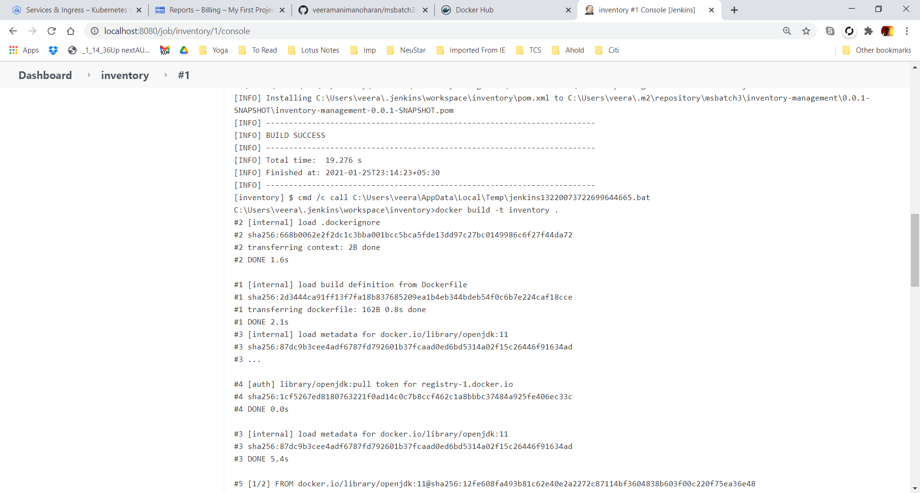

# Docker Images

Docker image on the local build b Jenkins

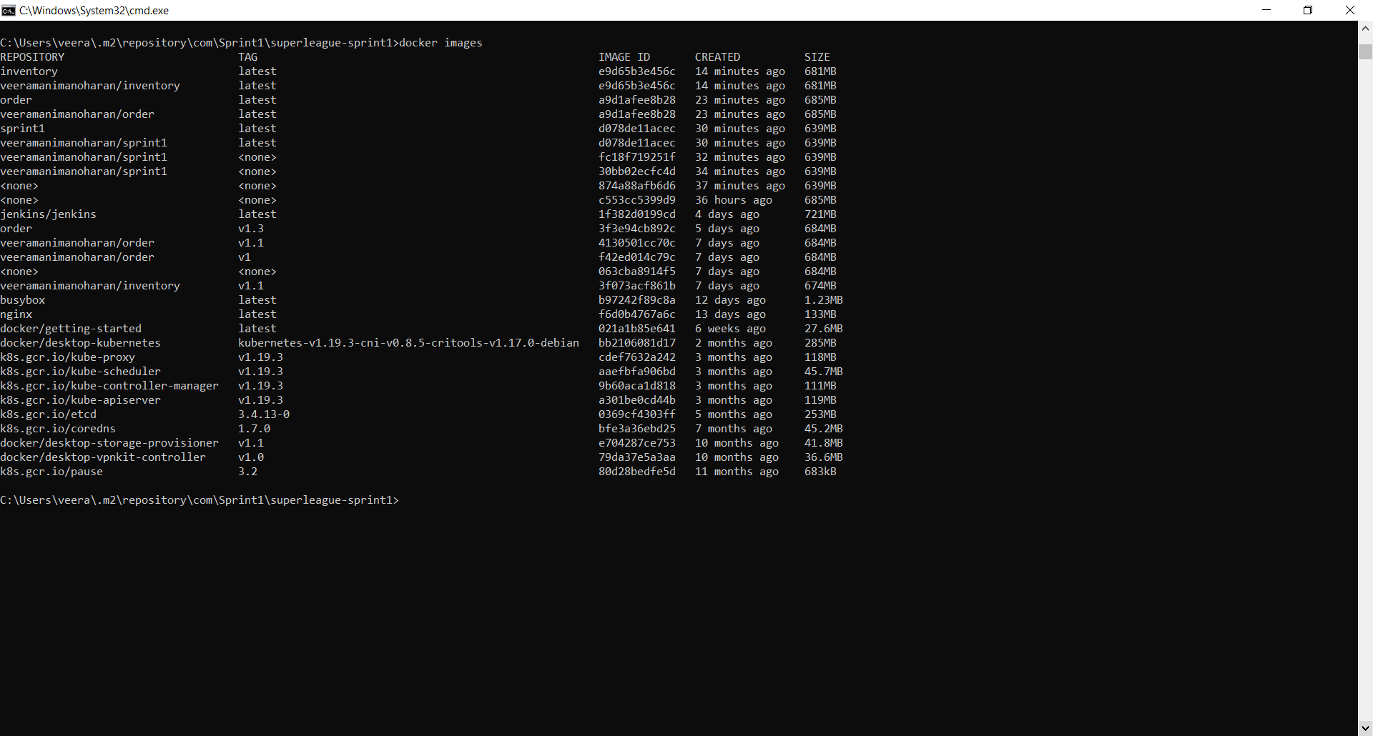

Docker image uploaded by Jenkins into DockerHub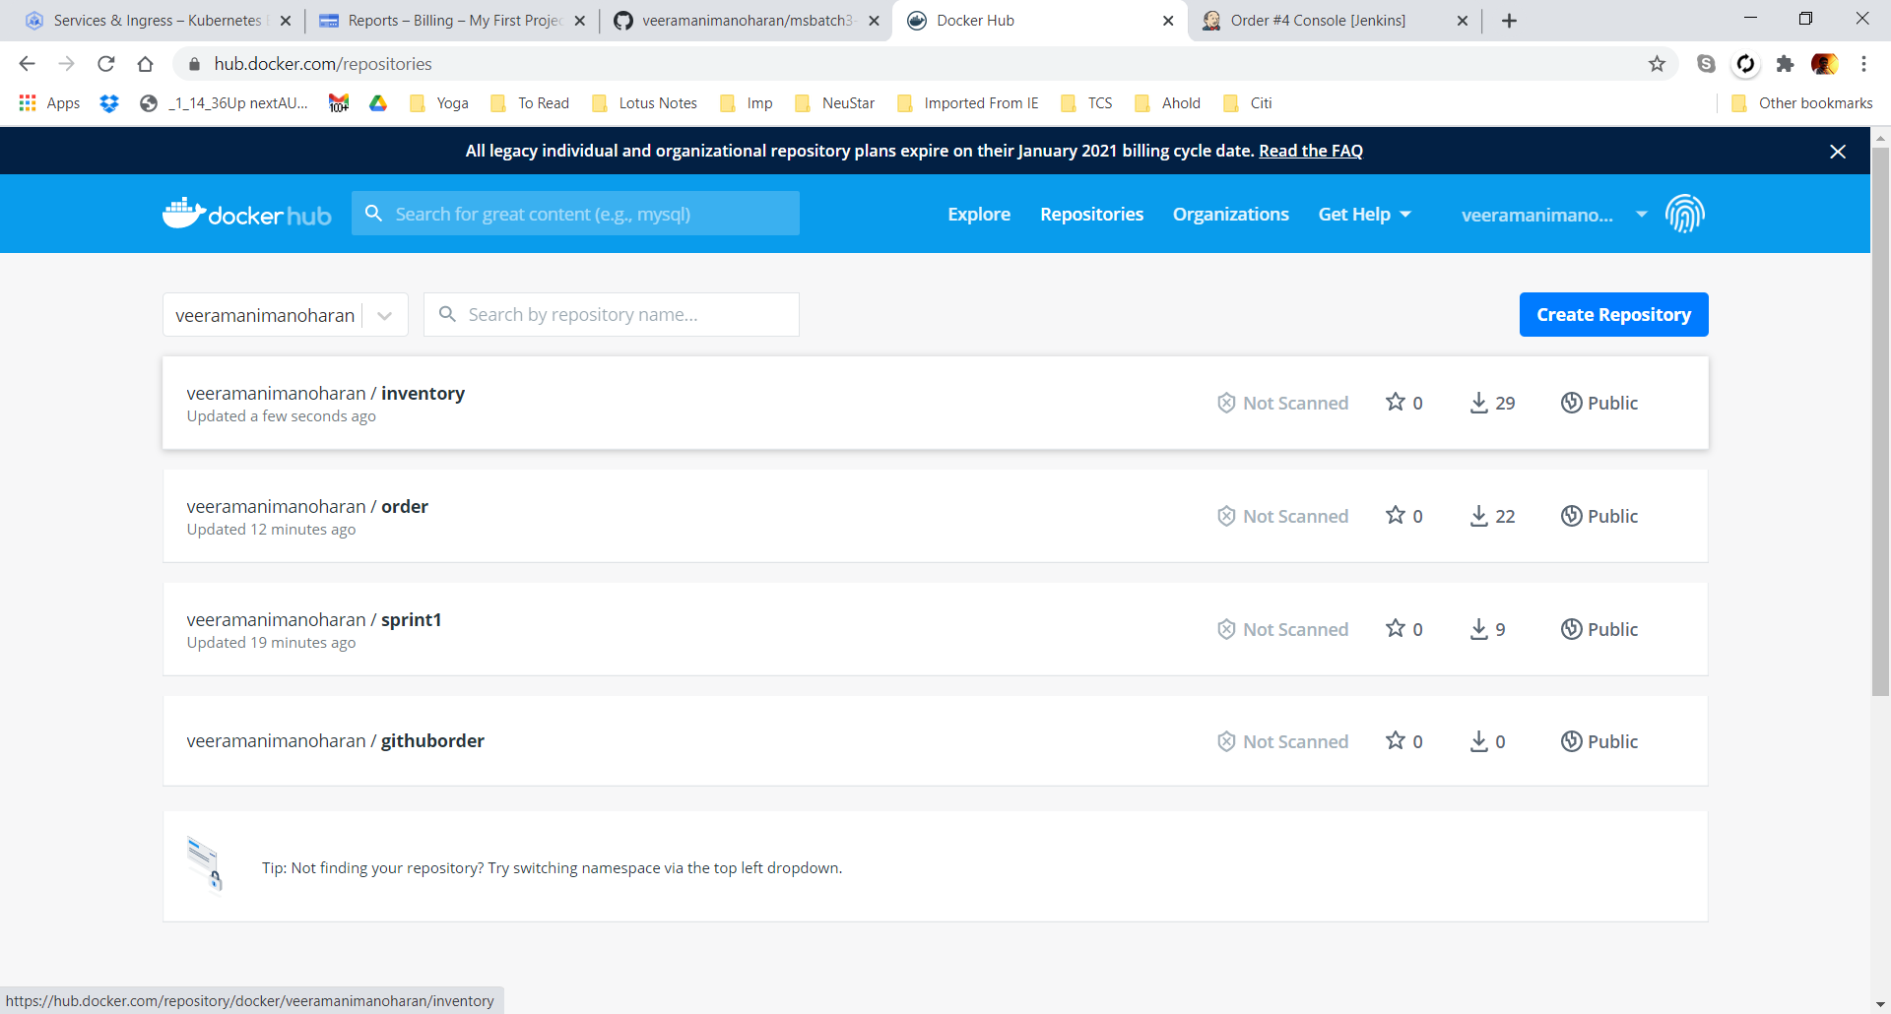

# Service as Kubernetes in GCP

Deployed order and Inventory images into GCP from docker Hub

3 pods running in Google cloud for both order and inventory

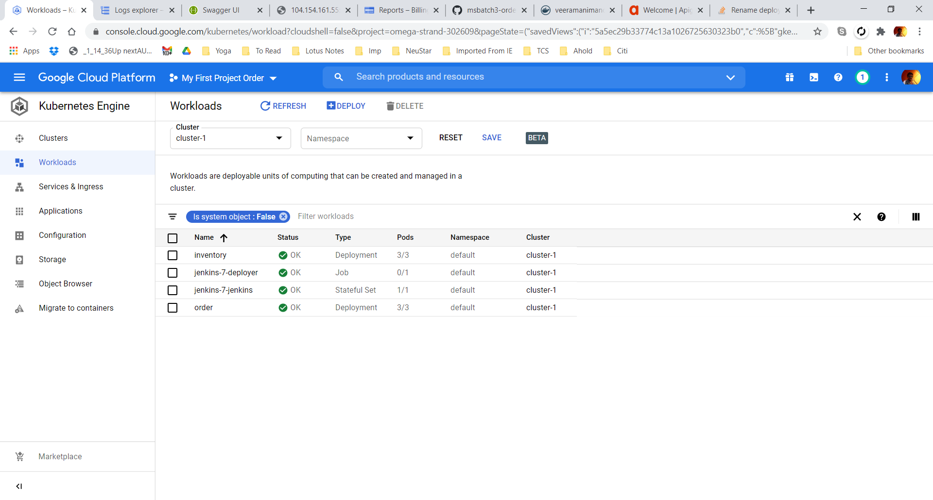

Service with load balancer 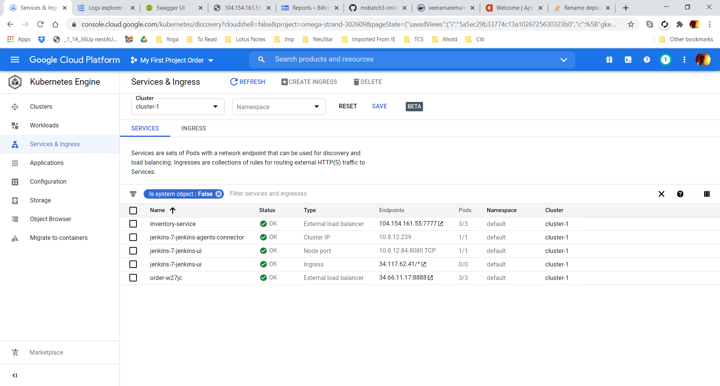

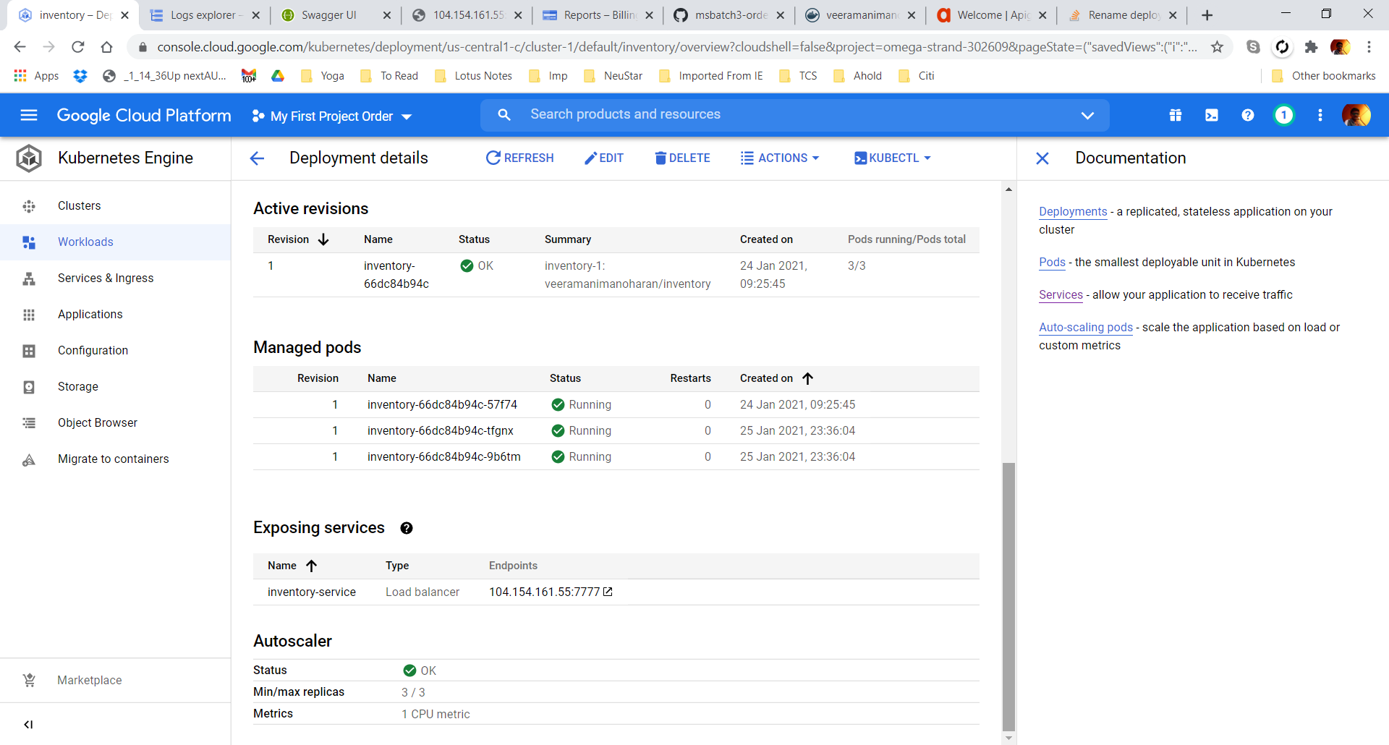

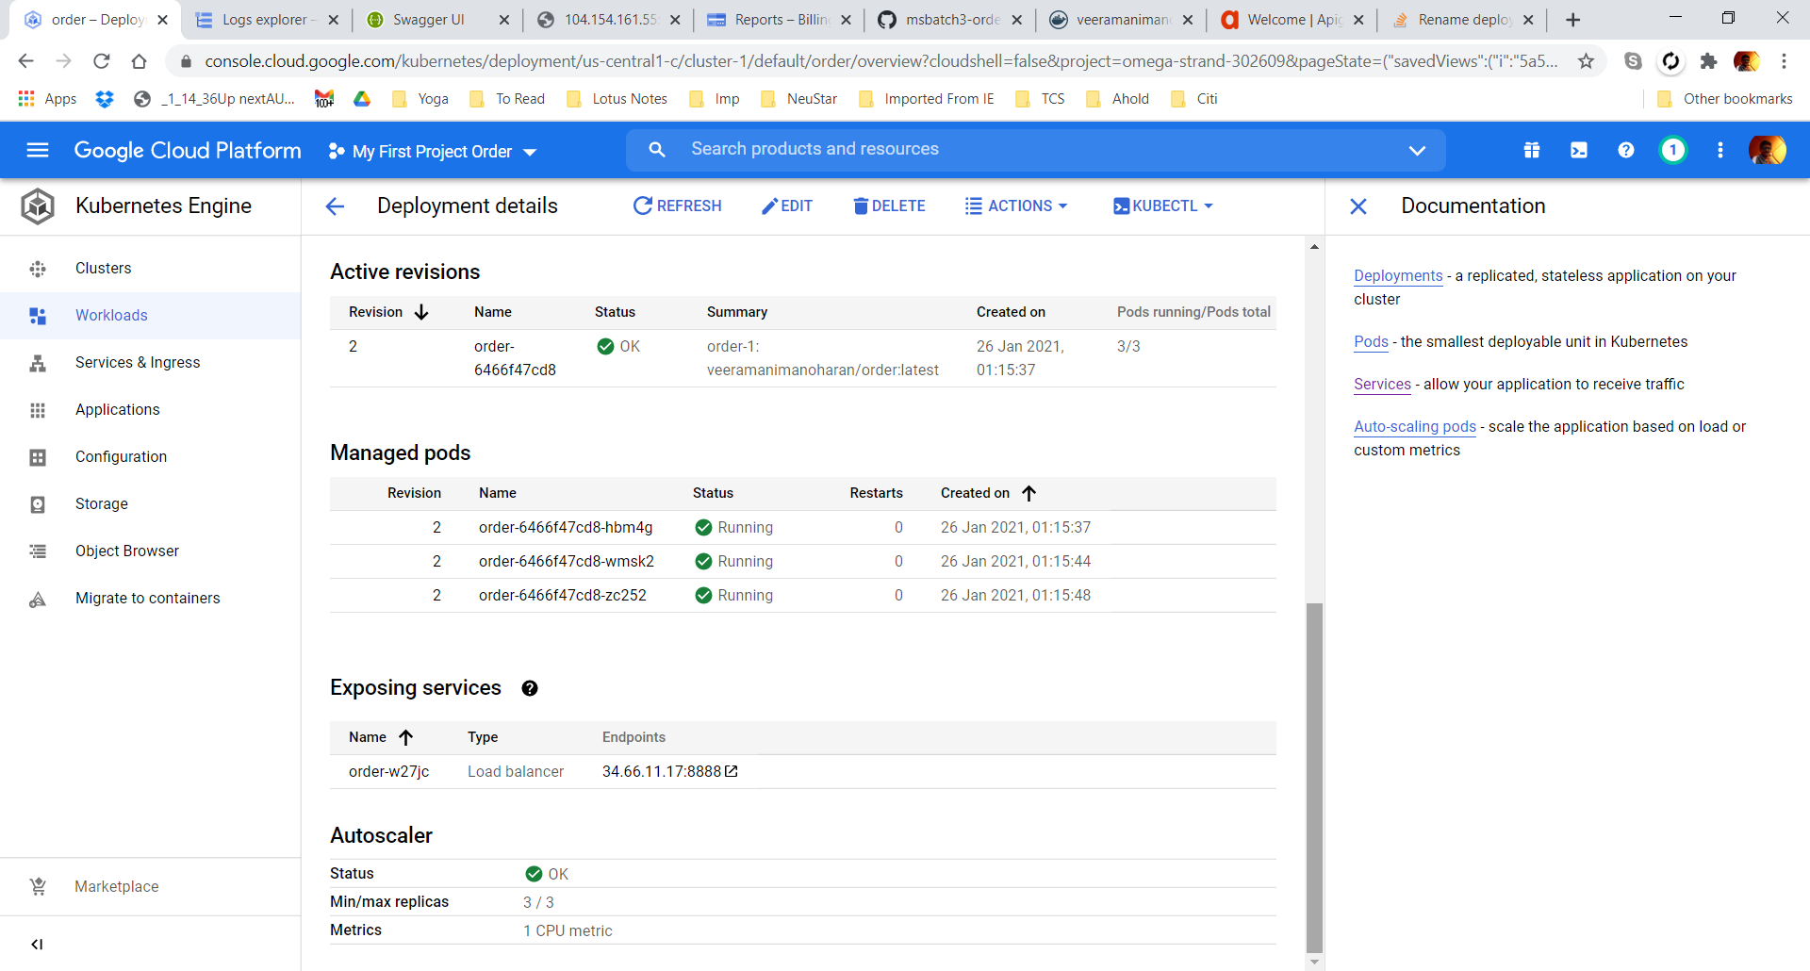

Deployment YML file

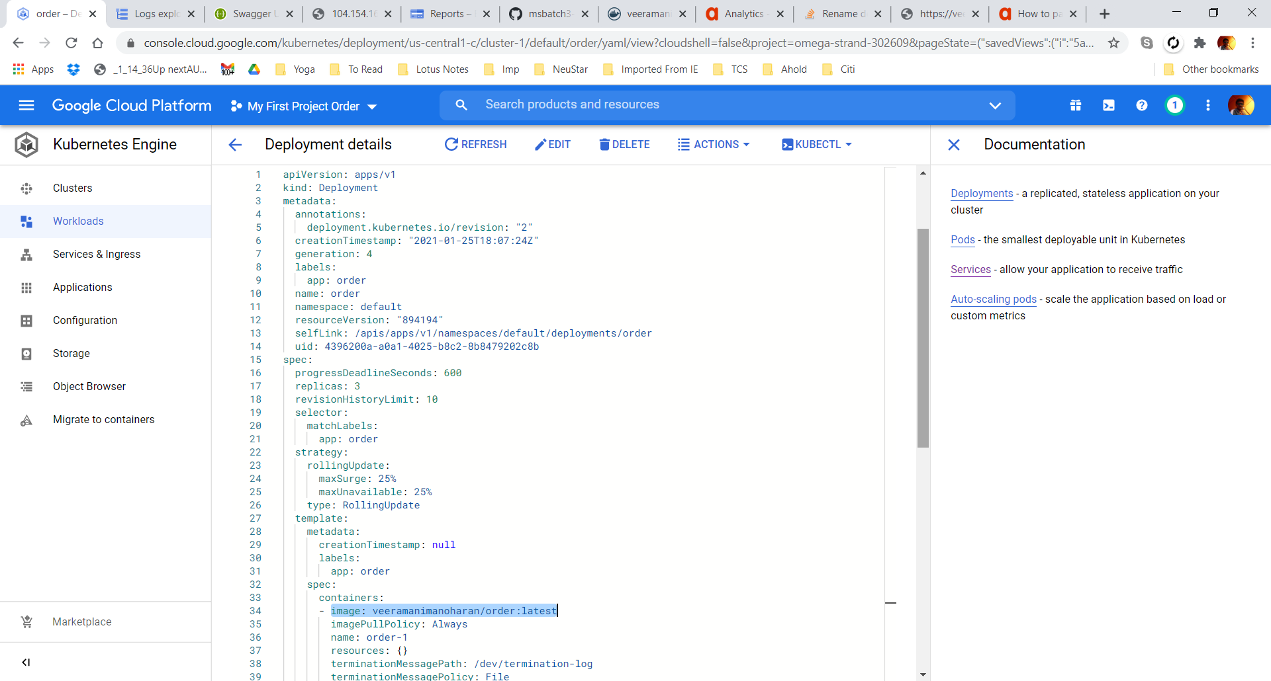

# Swagger Endpoint

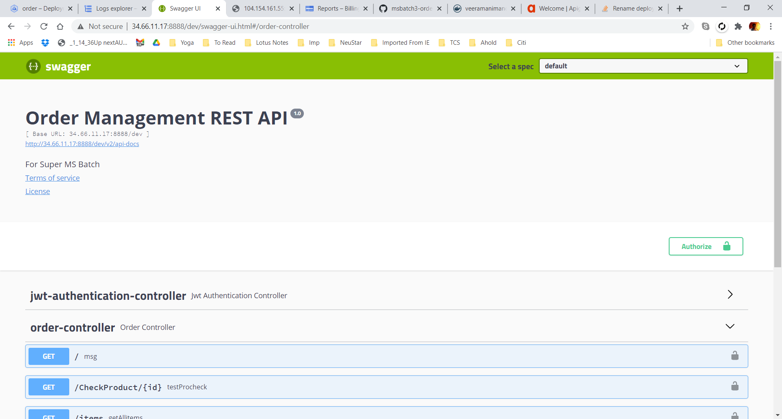

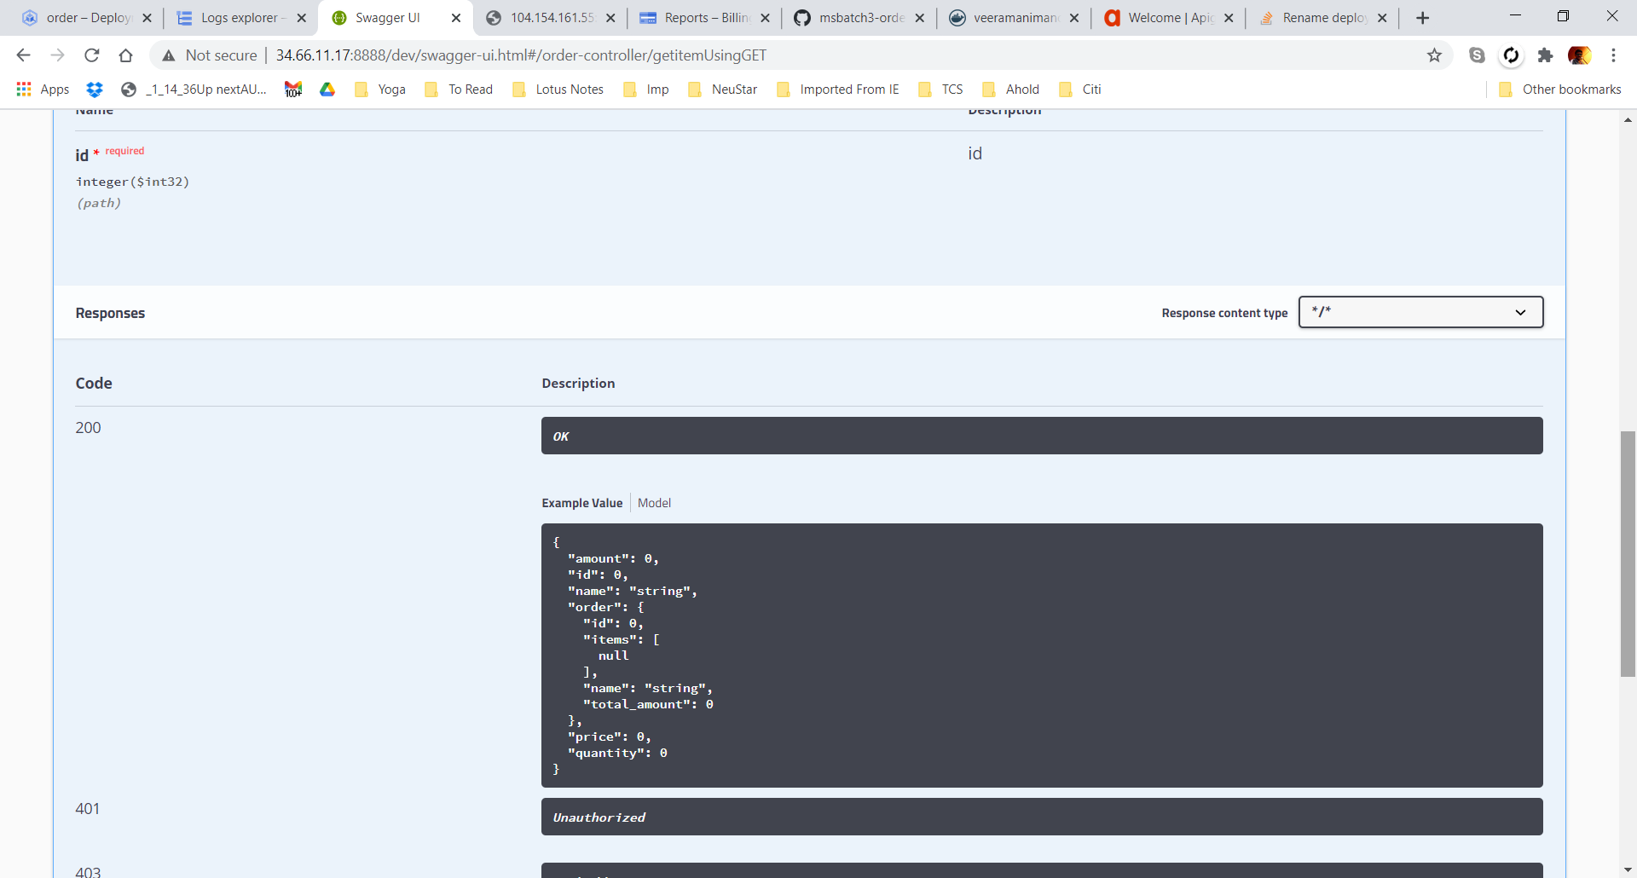

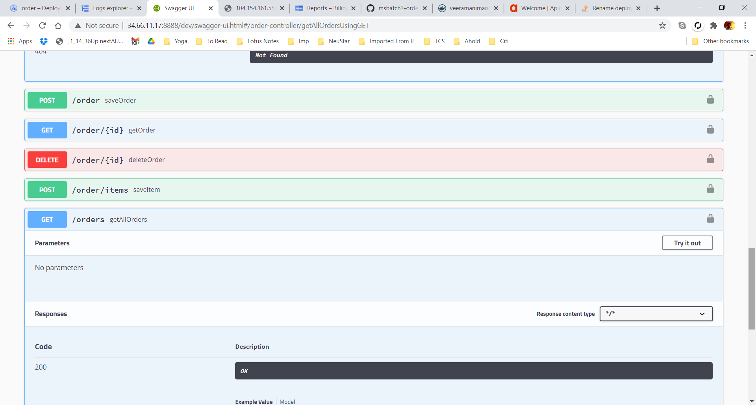

# Postman Endpoints

## Order

Authenticate

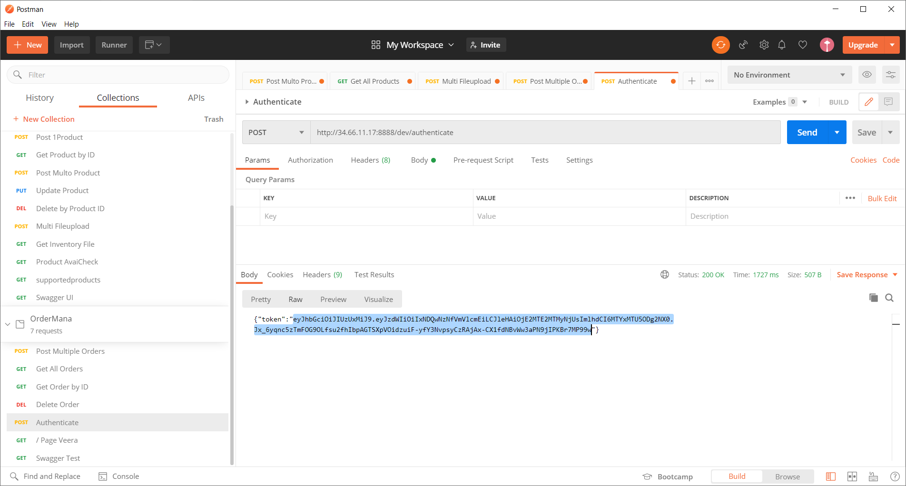

Unauthorize error using old JWT

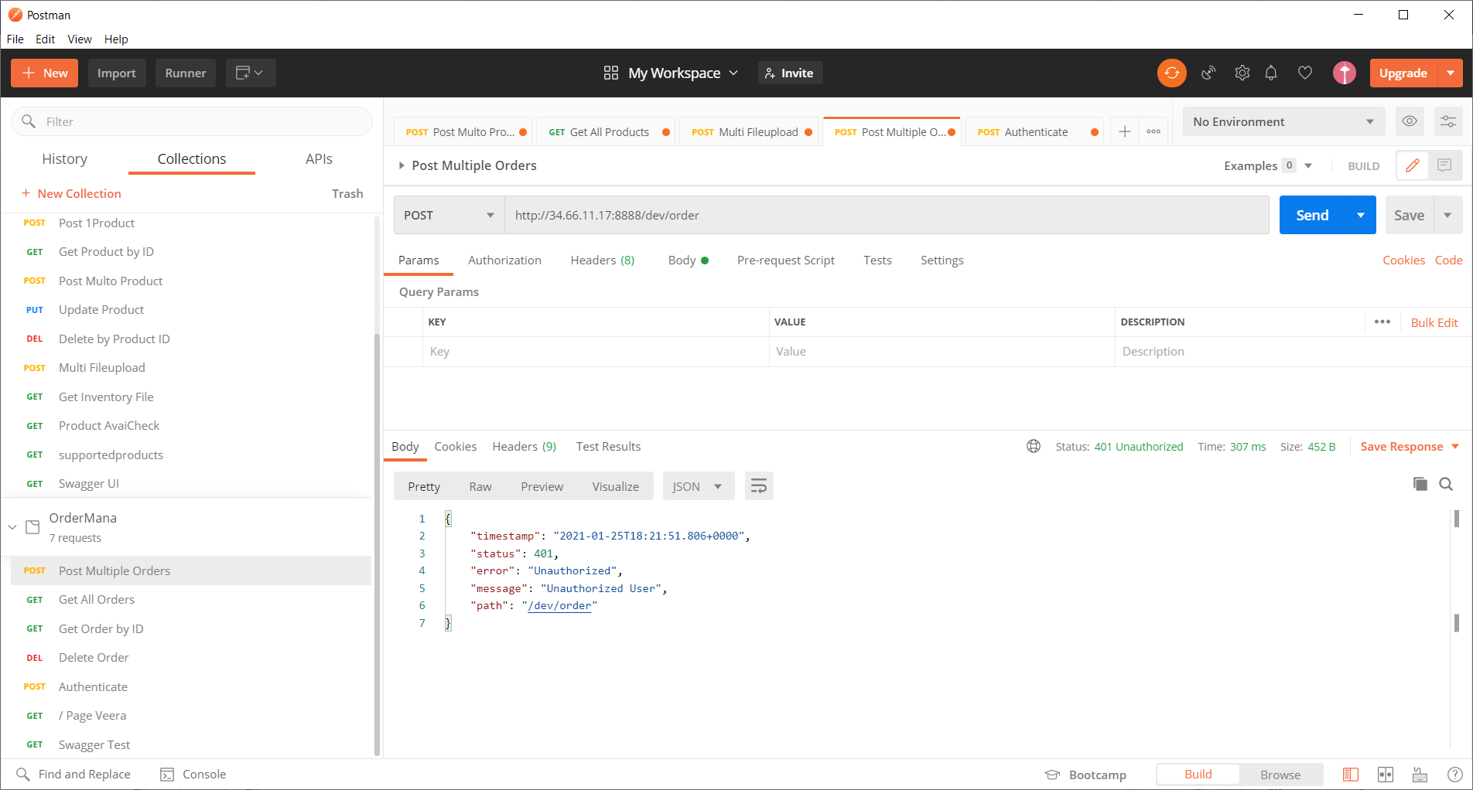

Posting order

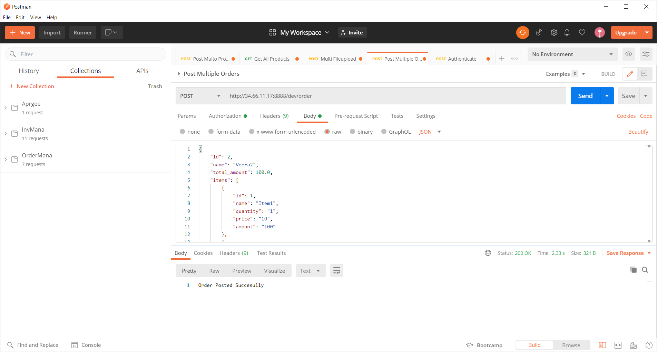

Get All Orders

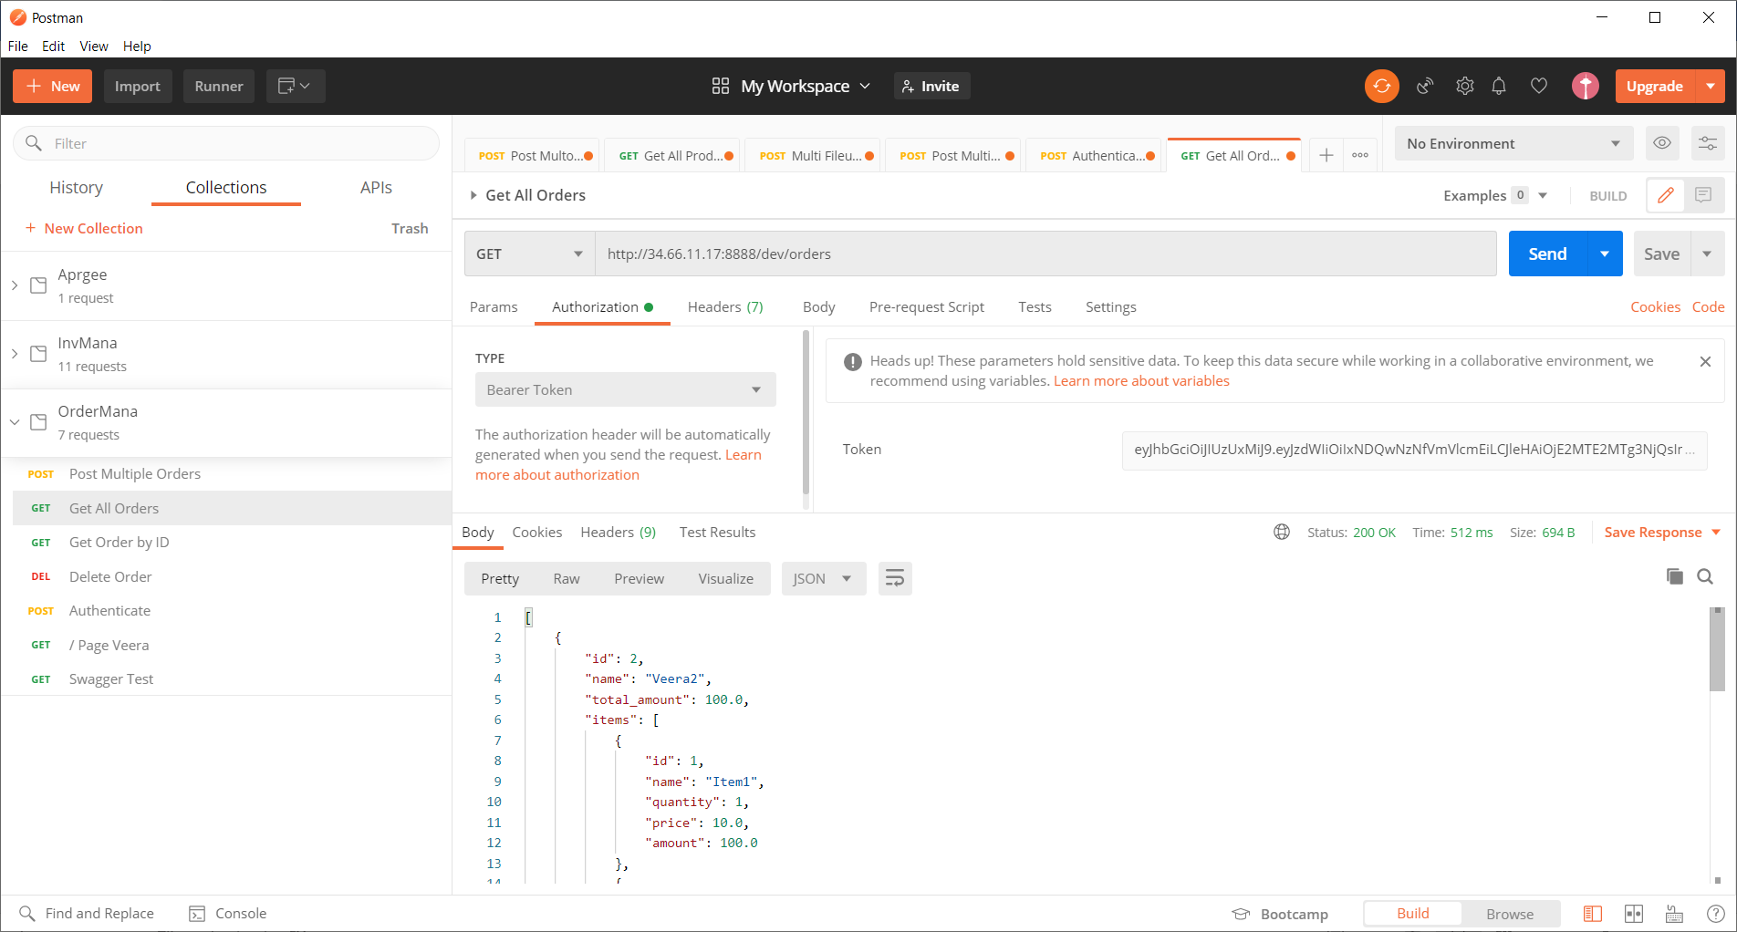

Product no available

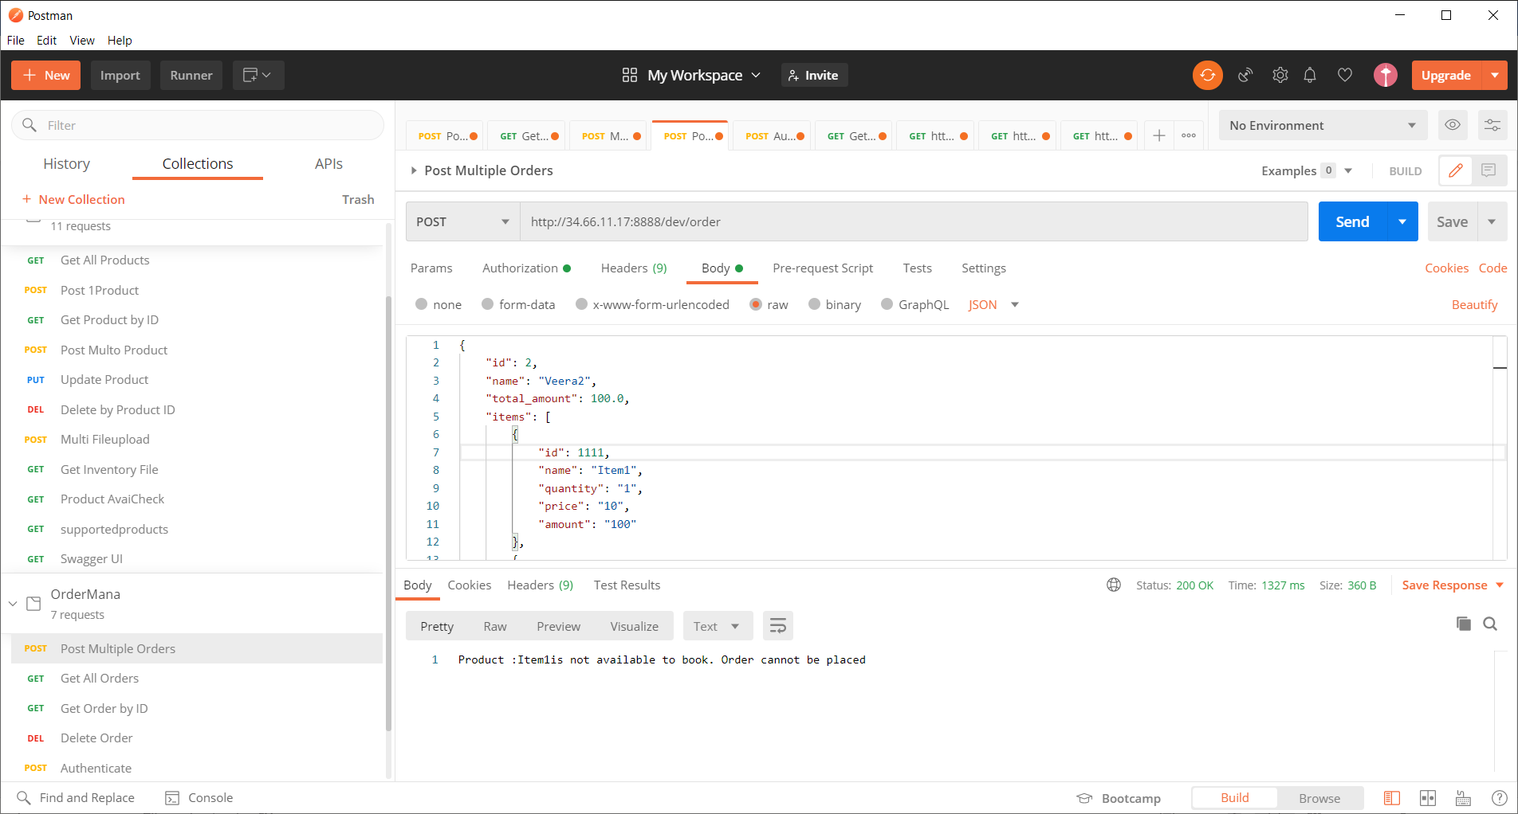

## Inventory

Posting multiple file

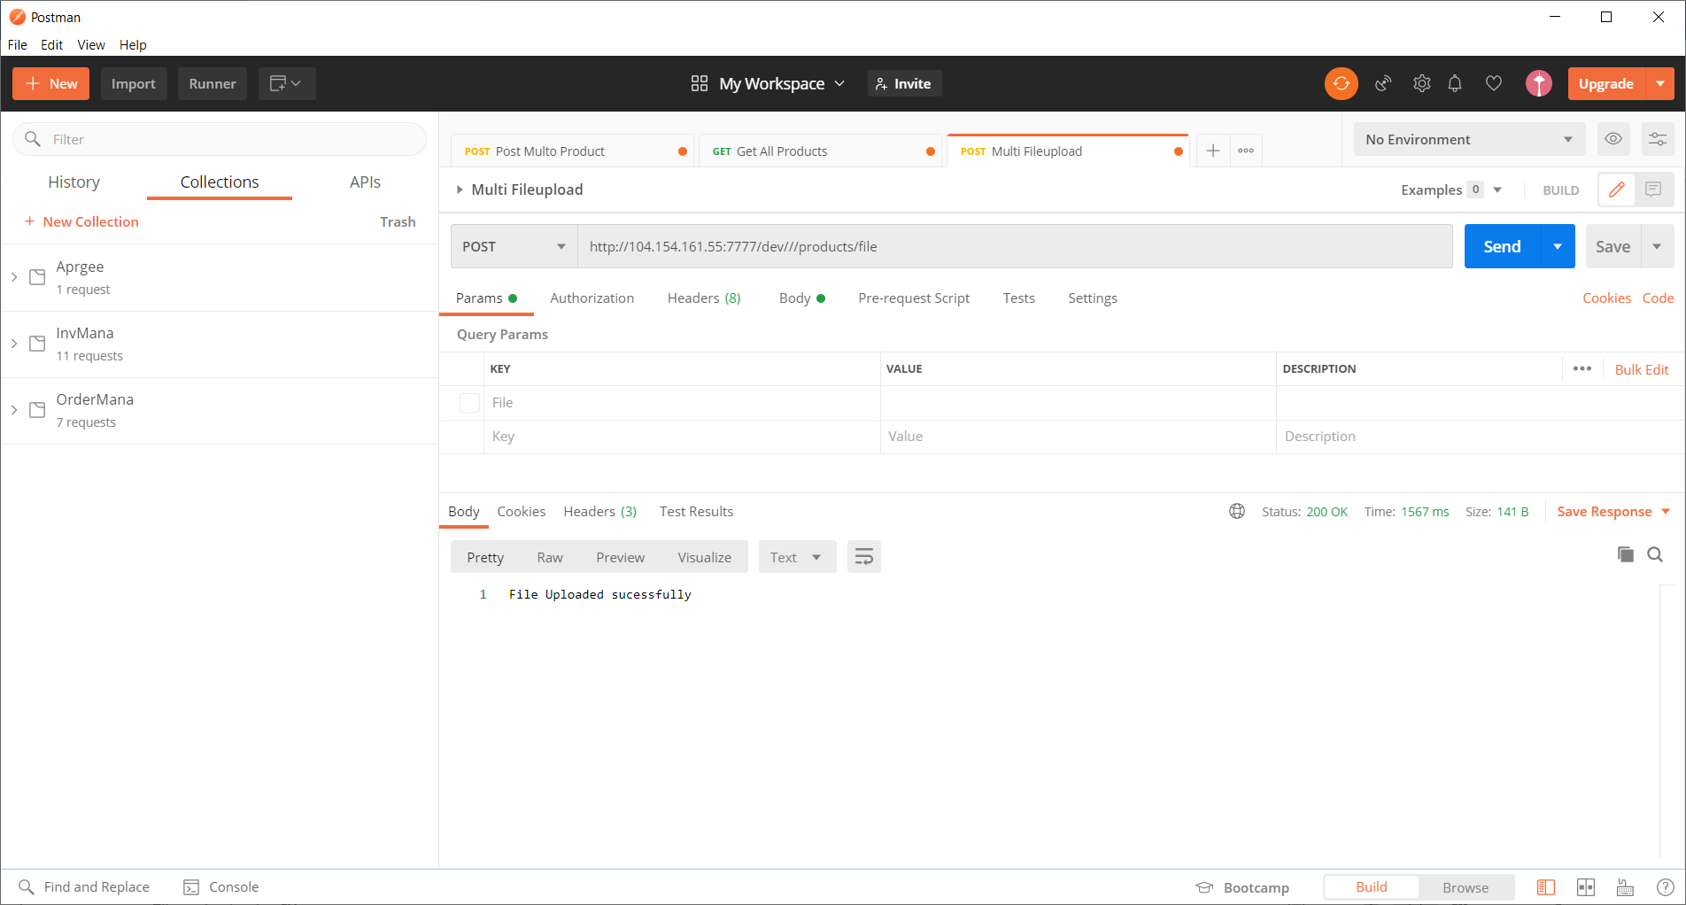

Get all products

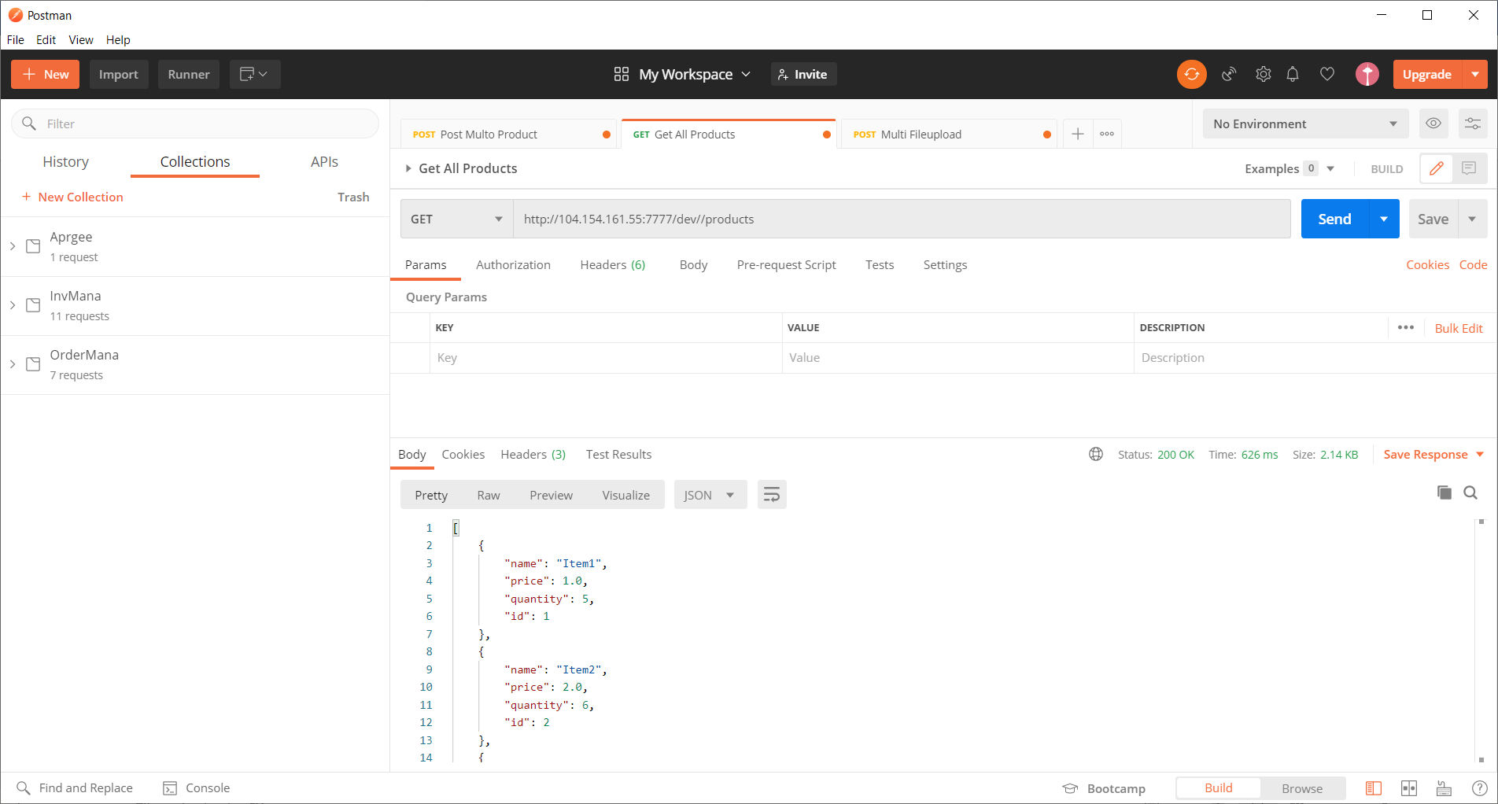

# Apigee proxy for Kubernetes

Proxy for Orders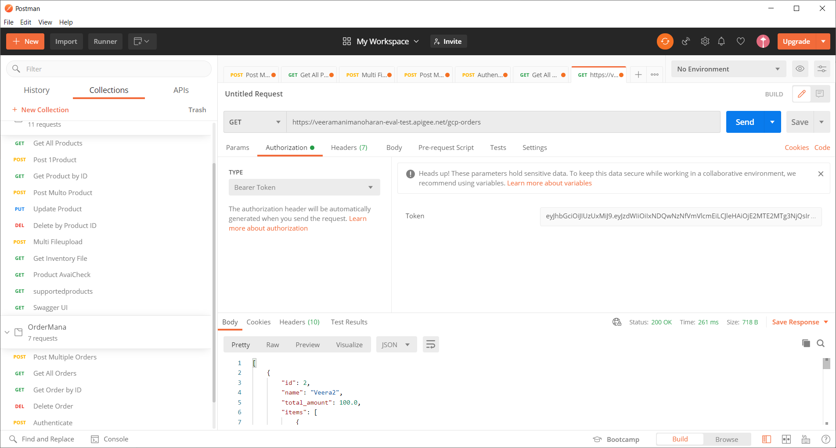

Proxy for inventory products

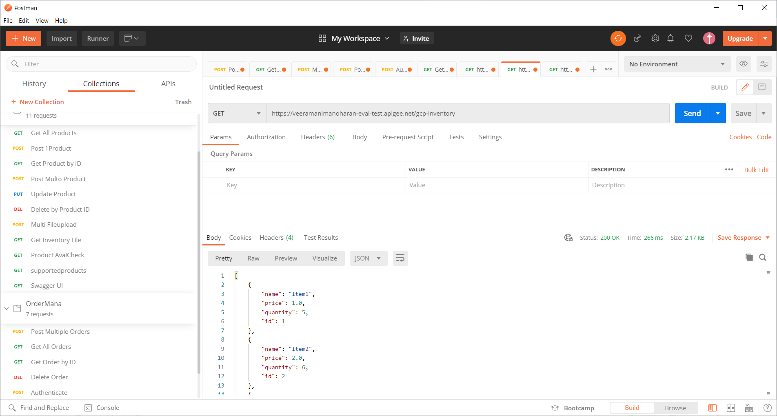

Proxy to convert JSON to XML with policy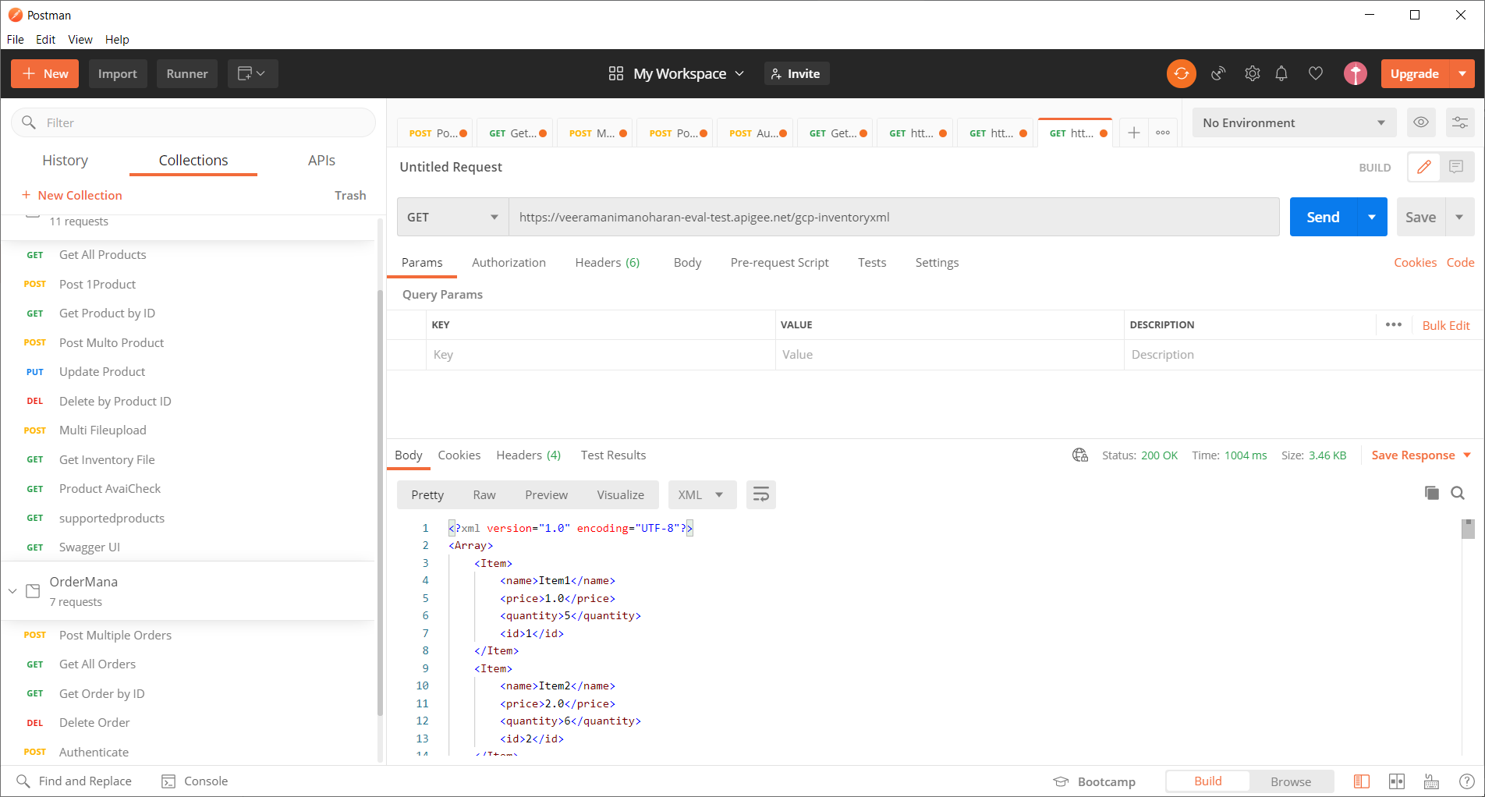

Some Metrics

